Document Project

RDA-902 Document Project

Contents

1. Purpose 2

2. Technical-functional description 2

2.1 Defining Entities 2

2.2 Description of characteristics for each entity 2

2.2.1 User 2

2.2.2 Institute 3

2.2.3 Project 3

2.2.4 Document 3

2.3 Definition of the DB 4

2.4 Description of functions 5

2.5 GUI templates 6

# Purpose

This document defines the implementation specifications of the new "Document Project" program. This document defines the entities and objects of program management, the characteristics of the entities, the functions and the graphical interface, also the data model (DB).

# Technical-functional description

"Document Project" is a product that allows you to upload several documents to a server and attach them to different institutions. The uploaded documents will be available for bank operators to download. In the graphical interface, the documents will be grouped on the following attributes: institution (bank), date (year and month), additional property. There will also be a module visible only to program administrators where you can manage all users and institutions.

## Defining Entities

The following main programme management objects have been taken:

* User – the entity describing the user of the program
* Institution – the entity that describes the banks to which several documents are attached
* Document – the entity that represents the base object that is managed in the program
* Project – the entity that represents a project, additional characteristic for documents of a certain MACRO type

## Description of characteristics for each entity

## User

The user is the user of the program. There are 3 user groups:

* Administrator – manages program users and institutions
* Cedacri operator – manages documents, uploads documents
* Bancare operator – attached only to an institution, can only download documents attached to the same institution

The user as a management object is described by the following attributes:

* Identifier – unique, numeric identifier
* User name – the username of the user (username) alphanumeric, maximum (32)
* Name, Surname, Patronymic **???**
* Password – the password of the user with whom he logs into the program, alphanumeric
* Email address – the email address
* Type – group to which the user belongs (administrator, Ced operator, bank operator), the same user can be included in all three groups **???**
* Institute – the bank to which the user is attached (it is valid only for users who are part of the banking *operators group*)
* Enabling – a flag that shows whether the user is enabled or disabled in the system

## Institute

The institution represents the bank to which the banking operators and the documents received in the system will be attached. The bank, as an object of management, is described by the following assets:

* Identifier – unique, numeric identifier
* Code – unique alphanumeric code of the bank, alphanumeric, maximum (5) **???**
* Name – name of the bank, alphanumeric, maximum (...)
* Additional – additional information **???**

## Project

Project represents the entity to which documents that have the MACRO Type = Design are attached (for details see 3.2.4 Document). The project is created by Cedacri operator. It is described by the following attributes:

* Identifier – unique, numeric identifier
* Name – the name of the project, alphanumeric, maximum 255
* Institute – reference to the bank with which the project is connected
* User – reference to the user who created the project
* Date from – date from which the project was started
* Date to – date until the project was started
* Additional information – a brief description of the project, maximum alphanumeric 1000
* Active – flag that shows us if the project is enabled or not (in case the due date has not arrived yet, but the project is not already a valid one)

## Document

Document represents the basic object of system management. The document is attached to an institution and uploaded by a Cedacri operator, which is available for download for bank operators attached to the same institution. The following document types are provided:

* Service Report:
  + Network
  + Safety
  + Change
  + Backup
* Report SLA
* Design:
  + Analysis
  + Transition
  + Production
  + Test
  + Monitoring

Document as a management object is described by the following attributes:

* Identifier – unique, numeric identifier
* Institute – the institution to which the document was attached, reference to institute
* Operator – the user who uploaded the document, reference to operator
* Project – reference on project to which the document is attached (valid only for macrotype = DESIGN)
* Name – the name of the file, document, alphanumeric, maximum (260)
* Upload date – date when the document was loaded into the system
* Document type – document type, referenced on one of the values enumerated above
* Path to save the document – complete path where the document is saved. You need to develop an algorithm to save the document (a root folder/BANK/YEAR/MONTH/DocumentName + Type + something....
* Additional information – some additional, alphanumeric or text information
* Date by grouping – date on the basis of which the document will be grouped in the graphical interface of the user **???**

## Definition of the DB

The DB diagram is shown in drawing 3.3.1. The file with the script to create all objects in the DB is located in object 3.3.2.



DES. 3.3.1 The DocumentManagement database diagram



Object 3.3.2 The file with the script that creates all the tables in the DB with the name DocumentManagement

## Description of functions

**TO COMPLETE**

## GUI templates

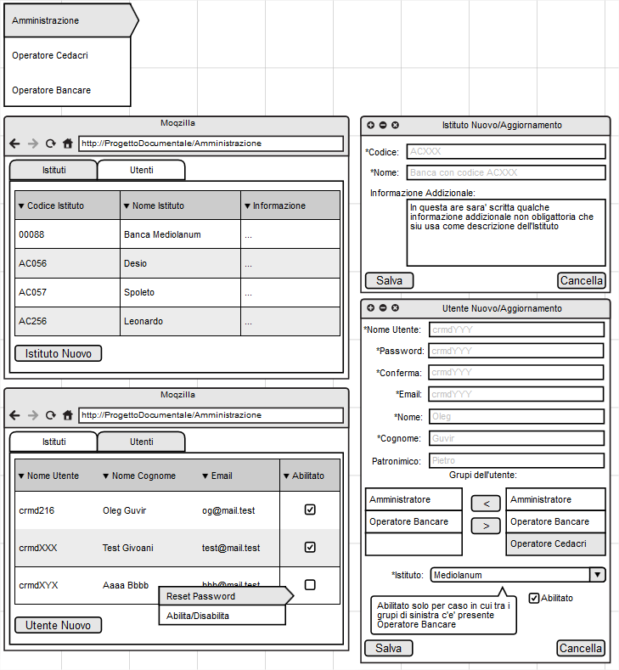

DES. 3.5.1 Graphical interface for the system administrator

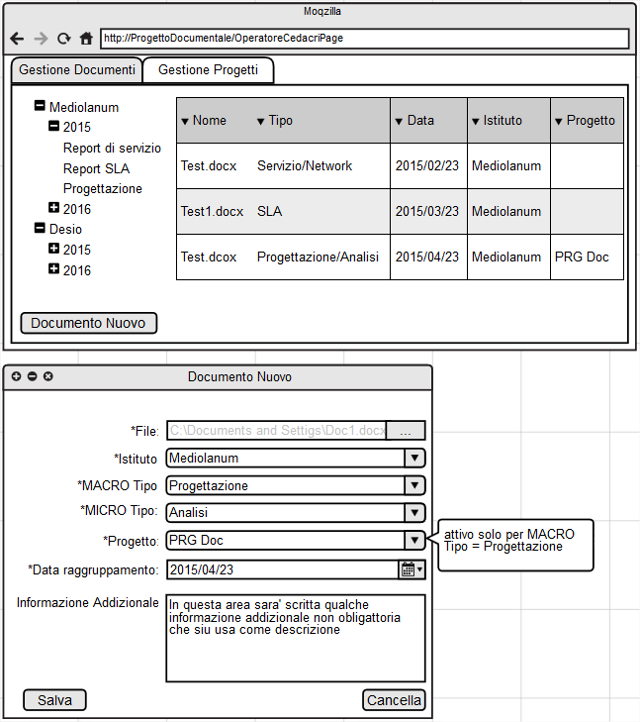

DES. 3.5.2 Graphical interface for the Cedacri operator, document management

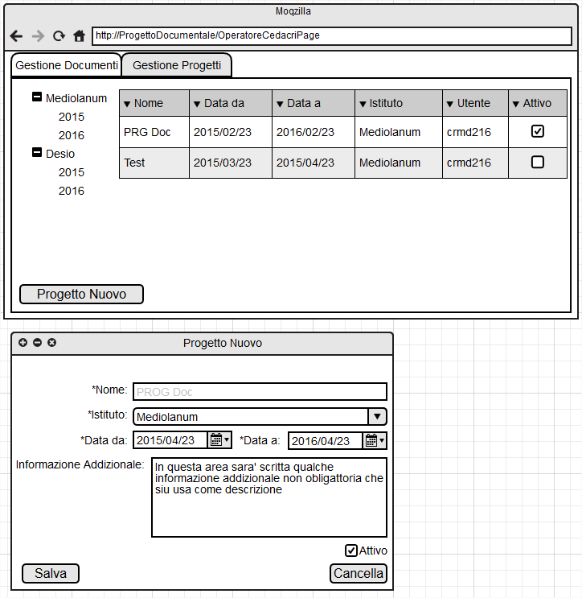

DES. 3.5.3 Graphical interface for the Cedacri operator, document management

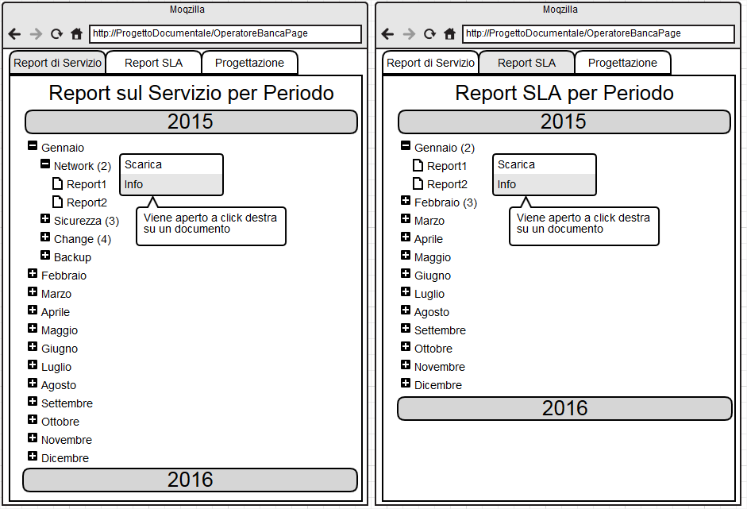

DES. 3.5.4 Graphical interface for the bank operator, Service Reports and SLA Reports documents

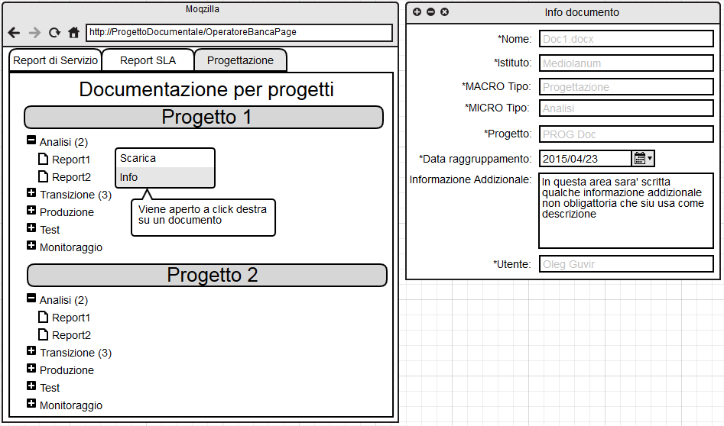

DES. 3.5.5 Graphical interface for the bank operator, documents for projects and the document details window